Rain Gutter Regatta Rules

April 19, 2020

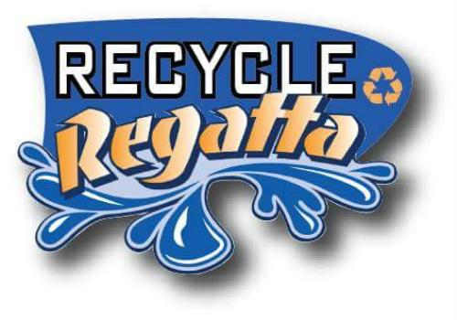
Official Rain Gutter Regatta Rules
CUB SCOUT PACK 94
1. Overview – “Just what is a Rain Gutter Regatta?”
The Rain Gutter Regatta is a boat race that is designed to be a parent-scout project. Please feel free to give guidance and minimal assistance to your Scout as they build their Rain Gutter Regatta boat, age appropriately. This is a chance for your scout to be part of a team, and to enjoy the spirit of friendly competition with their peers. These “Official Rain Gutter Regatta Rules” are written to help you keep it simple and fun for your child, and to know what to expect when it comes time to race your boat.
2. Ground Rules for Participation – “Who can race?”
Here are our participation guidelines:
a. The race is open to all paid and registered scouts to Pack 94 and siblings.
b. Each scout may enter only one boat in the competition. They should have a significant level of participation in building their boat (designing, building, gluing, painting, decorating, etc.).
c. The boat must have been built during the current program year (the school year in which the Regatta is held). Boats that have competed in a previous regatta races are not permitted.
d. Boats are powered by the scouts blowing into them only. No use of hands except to turn the boat around and race back. It will be a double elimination race against scouts of their own ranks. 1st, 2nd and 3rd place ribbons will be awarded at the end.
e. Be sure to name your boat. A boat without a name is bad luck. “S.S” denotes sailing ship – other historical or military designations (“U.S.S.” or “H.M.S.”) are allowed so have fun with it!
3. Boat Specifications – All boats are to be made from recyclable, non-sharp materials. No Lego or premade boats or kits.
a. Hull: Length between 6” (minimum) and 7” (maximum); Width of no more than 3 1/2”. Hull should be made of materials that minimize water-logging during the race.
b. Mast: Height limit is 6 1/2” (maximum) from deck to top. Masts can be decorated.
c. Sail: Can be made of any material and cut to any shape. To eliminate dragging on the sides of the raceway, the sail width should not be wider than the boat.
d. Rudder & Keel: You can design any shape you want with any non-sharp material, but must not extend over 1” below the boat, to eliminate dragging on the bottom of the raceway.
4. Decorating: Boats can be painted or stained. No water based paints or other washable materials. All boats must be dry of paint and glues on the day of the race. Stickers and stencils can be used.
5. Where & When: The race will be held immediately after the April pack night at Marley Community Church
6. Helpful Hints: Check the internet for boat designs and ideas. In this race, the lighter the boat, the faster you will go!

Thank you and have fun!
Mike Drymiller
Cubmaster – Pack 94

